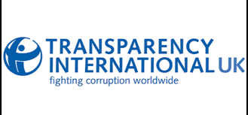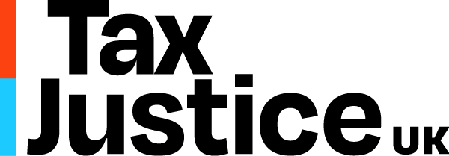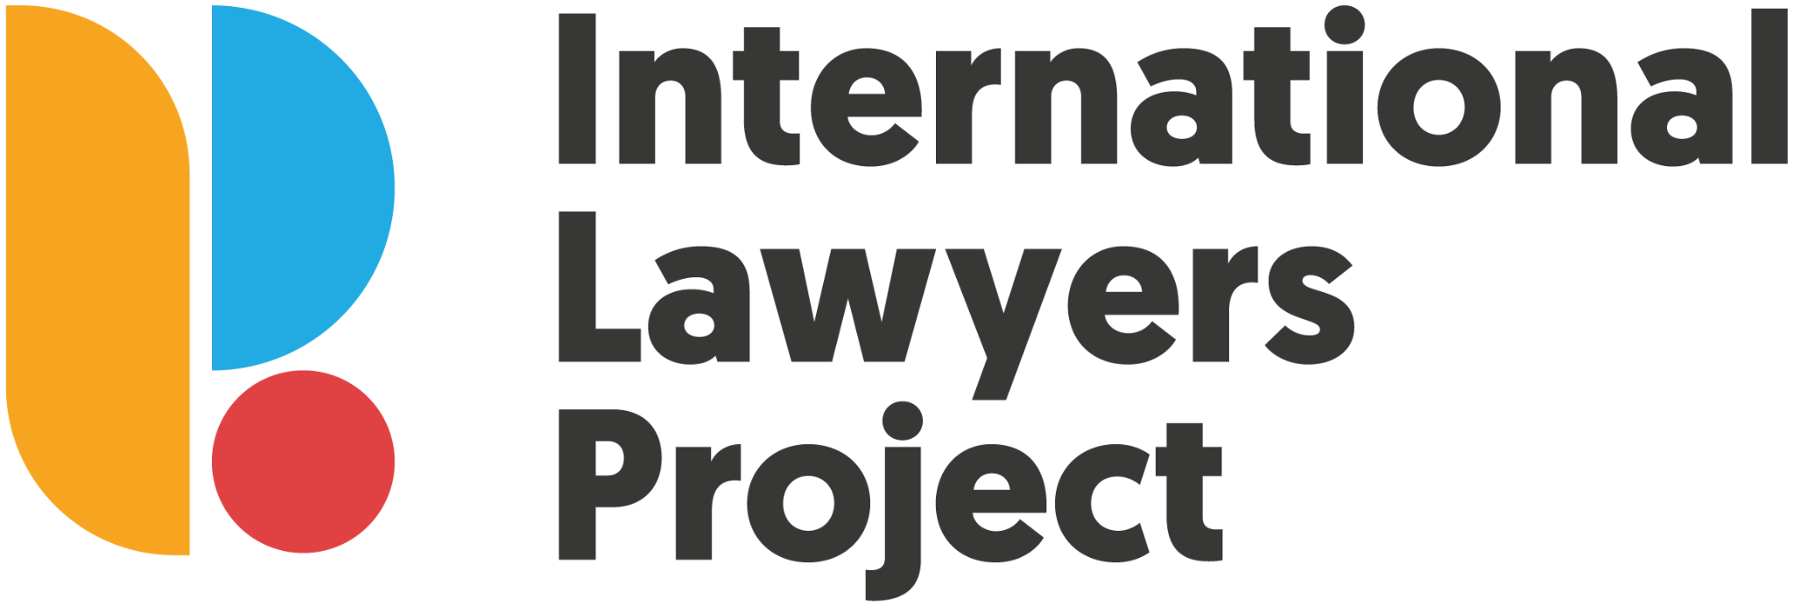

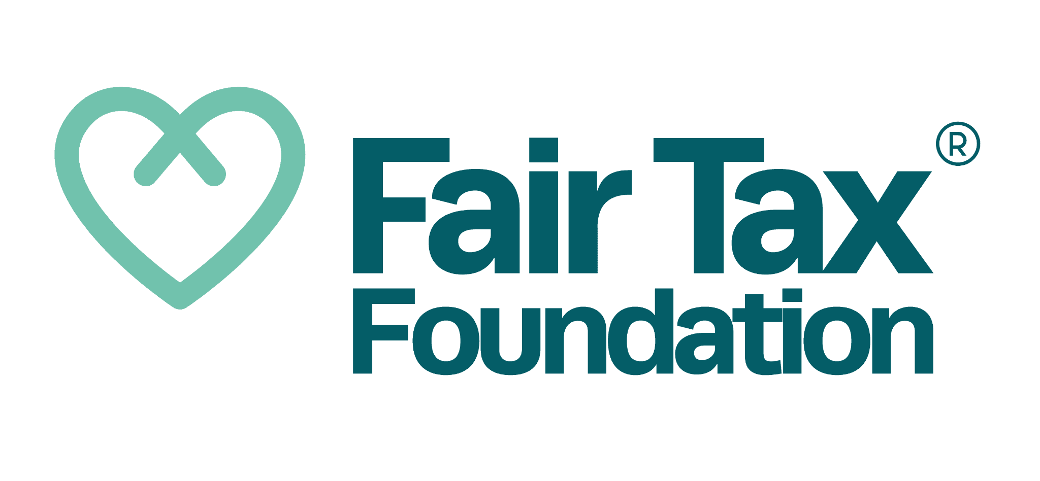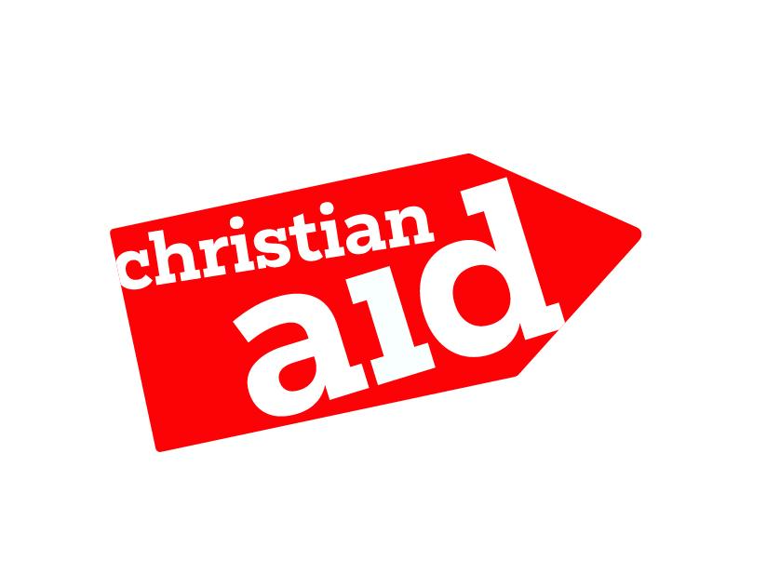



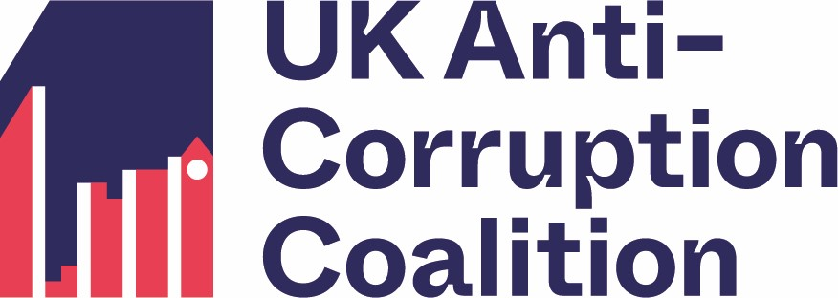

**-----------------------------------------------------------------**

**STATEMENT: THE UK GOVERNMENT MUST ACT NOW TO ENSURE THAT UK OVERSEAS TERRITORIES DELIVER ON THEIR COMMITMENTS TO FINANCIAL TRANSPARENCY**

*Tuesday 1 July 2025*

Today, key UK offshore financial centres – including the British Virgin Islands – have failed to meet a final deadline to introduce registers of beneficial ownership. This undermines the UK’s credibility on anti-corruption, damages our economy, weakens our national security, and fuels global injustice.

In particular, the British Virgin Islands (BVI) have made their [position](https://bvi.gov.vg/media-centre/bvi-publishes-policy-legitimate-interest-access-beneficial-ownership-register) unmistakably clear. Far from moving towards increased transparency and shining a light on economic crimes and tax abuse, their plans would not help tackle money laundering and actively place journalists and civil society actors at legal and physical risk. This is all the more concerning given that the BVI has recently been [added](https://www.simmons-simmons.com/en/publications/cmc0coiay00byuzu4dwhs0bst/british-virgin-islands-added-to-the-fatf-aml-grey-list) to the Financial Action Task Force grey list due to serious deficiencies in its anti-money laundering regime.

Bermuda, Anguilla, and the Turks and Caicos Islands also appear to have missed this critical deadline.

As the UK Government prepares to host an international [summit](https://www.gov.uk/government/speeches/the-foreign-secretarys-mansion-house-speech-2025) on illicit finance – and the Foreign Secretary seeks to stamp out what he has called the [“golden age of money laundering”](https://www.theguardian.com/politics/2024/nov/21/uk-asset-freezes-travel-bans-three-kleptocrats-david-lammy) – the continued resistance to transparency from British offshore financial centres cannot be ignored.

Without decisive action, dirty money will continue to flow through the UK’s backdoor, enabling organised crime gangs and money launderers to hide their wealth, evade sanctions, and damage the UK economy. Inaction will also see tax abuse and illicit financial flows continue to disproportionately harm lower-income countries in the Global South. This [undermines](https://taxjustice.uk/wp-content/uploads/2024/11/TJ-Africa-and-TJ-UK-Joint-Letter-to-Chancellor-Reeves-and-Foreign-Secretary-Lammy-OTs.pdf) efforts to achieve the sustainable development goals and fulfill the Government’s human rights obligations.

If any Overseas Territory continues to defy the will of the UK Parliament, the Government should be prepared to escalate its response. All legal and constitutional options should be on the table to ensure these commitments are delivered in full and without further delay.

To support this, the UK Government should clearly define what **meaningful access** entails. This includes the following principles, as a minimum:

* A beneficial ownership register that provides reliable, accurate, and timely information on the ultimate owners of registered entities.
* Open, repeated and generalised access for journalists, civil society organisations, academics, and others who play a key role in tackling money laundering and associated crimes, without undue barriers to effective access.
* Strong legal protections for those accessing and using the data to tackle money laundering and associated crimes in the public interest.

The Overseas Territories have noted the UK Government’s expectation and ambition that Publicly Accessible Registers of Beneficial Ownership (PARBOs) become a global norm and should continue to make progress toward this ambition.

SIGNED

UK Anti-Corruption Coalition

Transparency International UK

Finance Innovation Lab

International Lawyers Project

Spotlight on Corruption

The Fair Tax Foundation

Christian Aid

Tax Justice UK

/**ENDS**

***Background:***

* Overseas Territories first [committed](https://www.gov.uk/government/publications/overseas-territories-adopting-publicly-accessible-registers-of-beneficial-ownership/overseas-territories-progress-made-on-improving-transparency-and-addressing-illicit-finance-flows-explanatory-note) to introduce publicly accessible beneficial ownership registers (PARBOs) in 2020, following an amendment to the Sanctions and Anti Money Laundering Act (2018). This law required the UK Government to draft an Order in Council requiring Overseas Territories to introduce public registers of beneficial ownership if they failed to introduce them voluntarily. The UK expected all jurisdictions to have live registers by December 2023.
* At the [2024 Joint Ministerial Council](https://www.gov.uk/government/publications/uk-and-overseas-territories-joint-ministerial-council-2024-communique/2024-uk-and-overseas-territories-joint-ministerial-council-communique), the British Virgin Islands, Cayman Islands, Bermuda, Anguilla, and Turks and Caicos committed to provide access to their registers for those who can demonstrate a legitimate interest in tackling money laundering and its predicate offences – an approach adopted by the EU in its sixth anti-money laundering directive (AMLD6). They agreed to have legislation in place by April 2025, and for the implementation of these registers by the end of June 2025.
* The British Virgin Islands, Bermuda, Anguilla, and Turks and Caicos are among those who have now missed this critical deadline.
* The Cayman Islands has respected the deadline, but their register falls short – as it doesn’t allow meaningful and repeated access to journalists, civil society organisations and academics.
* As of today, only Gibraltar and Montserrat have PARBOs.

***Why this matters:***

* Transparency International UK [identified](https://www.transparency.org.uk/publications/cost-secrecy) 237 large corruption cases from the last 30 years that used shell companies registered in our Overseas Territories. In total, these schemes inflicted £250 billion of economic damage across 79 different countries.
* According to data provided by the Serious Fraud Office in a correspondence to the APPG on Anti-Corruption & Responsible Tax, **one in four** of their cases has a key entity registered in the British Virgin Islands.
* [Recent](https://assets.publishing.service.gov.uk/media/67f7d42804146682e61bc80f/OFSI_Property_and_Related_Services_Threat_Assessment.pdf?utm_content=&utm_medium=email&utm_name=&utm_source=govdelivery) [reports](https://assets.publishing.service.gov.uk/media/67ee635698b3bac1ec299c3e/OFSI_Legal_Services_Threat_Assessment.pdf) from the Office of Financial Sanctions Implementation (OFSI) found that 22 percent of all suspected sanctions breaches involved actors in intermediary jurisdictions – including the British Virgin Islands, Jersey and Guernsey.  The reports outline how some of those targeted by the UK government used complex layers of companies to transfer their assets and properties to family members, close associates or ex-spouses. TI-UK [identified](https://www.theguardian.com/business/2022/oct/03/campaign-government-oligarchs-assets-sanctioned-russians) **£700m** in UK property previously linked to sanctioned oligarchs that weren't flagged for asset freezes in the UK’s Register of Overseas Entities.
* Investigations have shown that [at least £5.9 billion](https://www.transparency.org.uk/news/new-analysis-reveals-role-overseas-territories-pumping-almost-ps6-billion-dirty-money-uk) in suspicious funds have been invested into UK property through shell companies registered in the Overseas Territories.
* In 2024, three UK Overseas Territories - the British Virgin Islands, the Cayman Islands, and Bermuda - were ranked at the top of the [Corporate Tax Haven Index](https://cthi.taxjustice.net/); the UK itself loses [US$45 billion a year](https://taxjustice.net/press/world-losing-half-a-trillion-to-tax-abuse-largely-due-to-8-countries-blocking-un-tax-reform-annual-report-finds/) as a result.
* This also harms lower-income countries in the Global South, undermining efforts to achieve the sustainable development goals and fulfill human rights obligations, as Tax Justice Network Africa [has warned](https://taxjustice.uk/wp-content/uploads/2024/11/TJ-Africa-and-TJ-UK-Joint-Letter-to-Chancellor-Reeves-and-Foreign-Secretary-Lammy-OTs.pdf).
* Companies with beneficial owners hidden behind British Virgin Islands-registered firms have destroyed more than 135,000 hectares of rainforest in Indonesia since 2008. [Multiple investigations](https://thegeckoproject.org/articles/how-secrecy-jurisdictions-are-facilitating-the-destruction-of-indonesia-s-rainforests/) have uncovered evidence suggesting that major plantation firms are secretly controlling these companies, allowing them to evade accountability for deforestation.